**A REPORT**

**ON**

**ANALYSIS OF RAINFALL IN INDIA IN THE YEAR 2022**

**BY**

**Vikram Muchumarri – AP21110011337**

***Prepared in the partial fulfillment of the***

Summer Internship Course

### **AT**

**APSSDC(Andhra Pradesh State Skill Development Corporation)**

**#3rd floor,Infosight Building,**

**survey No. 78/2,Near Pathuru Road Junction,**

**NH-16 Service Road, Tadepalli - 522501,**

**Guntur District,Andhra Pradesh**



**SRM UNIVERSITY, AP**

**(JULY,2023)**

#### Internship Completion Certificate:

#### This is to certify that the Summer Internship Project of Vikram Muchumarri titled Analysis of rainfall in in India in 2022 to the best of my knowledge is a record of bonafide work carried out by him under my guidance and/or supervision. The contents embodied in this report, to the best of my knowledge, have not been submitted anywhere else in any form for the award of any other degree or diploma. Indebtedness to other works/publications has been duly acknowledged at relevant places. The project work was carried during [June 19th] to [Aug 14th] in APSSDC.

|  |  |
| --- | --- |
| Signature of Faculty Mentor | Signature of industry Mentor/Supervisor |
| Name: Dr Mrityunjay Singh | Name: Ravi Kumar Gujjula |
| Designation: Assistant Professor | Designation: Chief General Manager, APSSDC |
| Place: SRM University -Andhra PradeshDate:11/10/23 | (Seal of the organization with Date) |

#### Completion Certificate:

#### 

#### Joining Report

**Date:  29-05-2023**

|  |  |
| --- | --- |
| **Name of the Student** | VIKRAM MUCHUMARRI |
| **Roll No** | AP21110011337 |
| **Programme (BTech/ BSc/ BA/MBA)** | BTech |
| **Branch** | CSE |
| **Name and Address of the Internship Company** | APSSDC(Andhra Pradesh State Skill Development Corporation)#3rd floor,Infosight Building,survey No. 78/2,Near Pathuru Road Junction,NH-16 Service Road, Tadepalli - 522501,  **Email:** compsecy-apssdc@ap.gov.in |
| **Period of Internship** | From [19-06-2023] to [31-08-2023] |

**I hereby inform that I have joined the summer internship on  19-06-23 for the In-plant Training/ Research internship in the industry.**



**Date:  19-06-23                                                                Signature of the Student**

#### 1.Acknowledgement

#### Completing the project is a collaborative effort that involves the support, guidance, and contributions of many individuals and organizations. I would like to express my special thanks to our mentor Mr Mrityunjay Singh for the time and efforts he provided us throughout the program.

#### His useful advice and suggestions were very helpful to us during the project’s completion. In this aspect, I am eternally grateful to my mentor.

#### I am deeply thankful to the entire APSSDC team for providing us with the necessary resources, facilities, and access to information. Their constant encouragement and belief in our abilities have motivated to strive for excellence in every aspect of the project.

#### I would like to acknowledge that this project was done with the help of my group mates. I would like to sincerely thank them.

#### 2.ABSTRACT

#### In this comprehensive analysis, our focus is directed towards understanding the intricate rainfall patterns that unfolded across India throughout the year 2022 We used information from different weather sources and the government.

#### By doing this, we found out where there was more rain than usual and where there was less rain than expected. This is important because rain affects things like water, farming, and buildings.

#### We learned that some places got too much rain, causing floods, while others didn't get enough, leading to problems with water for crops. We also saw that heavy rain could damage buildings and roads, costing a lot of money to fix.

#### By comparing this year's rain to past years, we could tell if things are changing. Overall, this study shows that understanding rain patterns helps us plan better for water, farming, and keeping our communities safe.

#### It reminds us of the importance of being ready for unexpected weather and taking care of our environment.

#### 

#### 3.TABLE OF CONTENTS

#### Contents Page no

#### 1.Acknowledgements-------------------------------------------------------4

#### 2.Abstract---------------------------------------------------------------------5

#### 3.Table of contents----------------------------------------------------------6

#### 4.Introduction of the organization’s business sector--------------------7

#### 5.Overview of the organization--------------------------------------------8

#### 6.Internship program plan -------------------------------------------------10

#### 7.Background and description of the problem--------------------------12

#### 8.Introduction----------------------------------------------------------------13

#### 9.Technical framework-----------------------------------------------------14

#### 10.Features and functionalities--------------------------------------------15

#### 10.1Outcomes------------------------------------------------------------17

#### 11.Conclusion-----------------------------------------------------------------18

#### 12.References-----------------------------------------------------------------19

#### 4.Introduction of the organization’s business sector:

#### The Andhra Pradesh State Skill Development (APSSDC) Operates within the dynamic and transformative field of skill development and vocational training. As a prominent player in the sector. APSSDC plays a vital role in shaping the future of the Andhra Pradesh’s workforce and contributing to the socio-economic development of the region. The sector encompasses a wide array of activities and initiatives that revolve around the enhancing the employability and capabilities of individuals aligning them with the needs of diverse industries

#### 4.1.Skill development sector overview:

#### The skill development sector is a critical component of India's growth strategy, addressing the need for a skilled workforce that can effectively contribute to the nation's development across sectors. In the Indian context, this sector recognizes the multifaceted demands of industries spanning manufacturing, technology, healthcare, tourism, construction, and more. The focus lies in equipping individuals with the right skills, knowledge, and attitudes to succeed in their chosen fields while also supporting the broader objectives of economic growth, innovation, and inclusivity. As a leading player in the skill development sector, APSSDC is committed to transforming Andhra Pradesh into a hub of skilled talent. By offering a wide range of skill development programs, apprenticeships, and training initiatives, APSSDC addresses the skills gap, reduces unemployment, and fosters economic growth. Through collaborations with industries, educational institutions, and government agencies, APSSDC ensures that individuals are prepared to contribute effectively to the workforce, thereby supporting the state's development objectives.

#### 5. Overview of the organization:

#### 5.1. Brief History:

#### Andhra Pradesh State Skill Development Corporation (APSSDC) is a dynamic organization dedicated to enhancing the employability of the youth in Andhra Pradesh, India. Established in 2017, APSSDC has emerged as a pivotal player in bridging the gap between industry requirements and workforce readiness. It was founded with the vision of empowering individuals with skills that are aligned with the ever-evolving demands of the job market.

#### 5.2. Business Size:

#### APSSDC operates on a large scale, impacting various sectors across Andhra Pradesh. With a comprehensive approach, APSSDC has trained and upskilled a substantial number of individuals, contributing significantly to the region's workforce development. The organization's business size can be gauged through metrics such as the number of training programs conducted, the breadth of industries covered, and the scale of partnerships established.

#### 5.3.Product Lines:

#### Skill Training Programs: APSSDC offers a wide array of skill training programs spanning industries such as information technology, manufacturing, healthcare, hospitality, and more. These programs equip individuals with practical skills and knowledge to enhance their employability.

#### Job Placement Services: Alongside training, APSSDC connects skilled individuals with job opportunities through its network of industry partnerships. This facilitates a smoother transition from training to employment.

#### Industry Collaboration: APSSDC collaborates with various industries to identify skill gaps and design training modules that align with the specific needs of employers.

#### Entrepreneurship Development: APSSDC also supports aspiring entrepreneurs by providing training, mentorship, and resources to help them establish and manage successful businesses.

#### 5.4.Competitors:

#### While APSSDC stands out as a major player in the skill development sector in Andhra Pradesh, there might be other organizations, both public and private, that operate in a similar space. These competitors may include regional skill development agencies, vocational training canter’s, and private training institutes.

#### 5.5.Summary of Departments:

#### APSSDC operates through various departments, each contributing to the organization's overarching goals. These departments include:

#### Industry Collaboration Department

#### Entrepreneurship Development Department

#### Research and Development Department

#### Administrative Department

**6.Internship Program Plan:**

During my internship with the Andhra Pradesh State Skill Development Corporation (APSSDC), I had the privilege of immersing myself in the world of Data analysis with python with wonderful visualizations and interpreting the raw data to customized data. Our primary task was to analyse the rainfall patterns across India in the year 2022, contributing to the enhancement of agricultural crops ,water and keeping our communities safe.

**Internship Duration**:

Start Date: 19-06-2023

End Date: 31-08-2023

**6.1.Duties and Responsibilities**:

#### During my internship, I actively participated in the analysis of the rain fall patterns with python and some modules such as pandas,numpy,matplotlib and seaborn . My duties and responsibilities included:

#### 6.1. Data Collection: Gathering historical rainfall data from various meteorological departments, research institutions, and satellite observations for the year 2022.

#### 6.2. Data Preprocessing: Cleaning and organizing the collected data to ensure consistency and accuracy.

#### 6.3. Statistical Analysis: Conducting statistical analyses, including mean, standard deviation, and trend analysis, to identify patterns and anomalies in the rainfall data.

#### 6.4. Spatial Mapping: Creating spatial representations, such as heatmaps and rainfall distribution maps, to visualize the geographic variations in rainfall across India.

#### 6.5. Temporal Analysis: Examining the temporal distribution of rainfall to identify seasonal patterns and trends.

#### 6.6. Climate Change Impact Assessment: Investigating the potential influence of climate change on the observed rainfall patterns.

#### 6.7. Implications and Recommendations: Drawing conclusions from the analysis and formulating recommendations for water resource management, agriculture, and disaster preparedness.

#### 7.Background and description of the problem:

#### 7.1.Background: India is a country that heavily relies on the monsoon season for its agriculture and water resources. The monsoon, which occurs from June to September, is a critical climatic phenomenon that determines the country's overall economic and ecological well-being. Understanding the patterns and trends of rainfall in India is of utmost importance to various sectors, including agriculture, hydrology, and disaster management

* **7.2.Description**:For this analysis, we adopted a quantitative approach and collected historical rainfall data from reliable meteorological sources for various regions in India during the year 2022. The data was carefully processed and cleaned to ensure accuracy. We used statistical techniques such as time series analysis and spatial mapping to identify patterns and trends in the rainfall data. The results were visualized using appropriate tools. Additionally, we considered key factors like seasonal variations and correlations with climatic events to gain meaningful insights into India's rainfall patterns in 2022 and their potential implications.

#### 8.Introduction

#### Rainfall is a critical climatic parameter that significantly influences the socioeconomic development of a country like India, where a significant proportion of the population depends on agriculture for their livelihood.

#### The country's economy relies heavily on the performance of the agricultural sector, making the availability and distribution of rainfall a matter of utmost importance.

#### Additionally, water scarcity and drought are recurring challenges faced by several regions, making it essential to have accurate rainfall data to implement effective water resource management strategies.

#### Understanding the spatial and temporal variations of rainfall is crucial for policymakers, water managers, and agricultural planners to make informed decisions.

#### By analysing the rainfall patterns in India during 2022, this project aims to provide valuable insights that can guide policymakers and stakeholders in formulating appropriate strategies for water conservation, distribution, and allocation

**9.Technological Framework**

**9.1. Pandas:**

* + Pandas is a crucial library for data analysis and manipulation. It introduces DataFrames, flexible data structures that simplify handling and cleaning of datasets

**9.2. Matplotlib.pyplot:**

* + Part of the Matplotlib library, matplotlib.pyplot is employed to create static, interactive, and
  + publication-quality plots and visualizations in Python. It aids in visually representing the analysis results.

**9.3.Calendar:**

* + Python module for working with dates and calendars. In this project we used Calendar
  + Library to convert the month number into usual month names

**9.4. Seaborn:**

* + Python data visualization library with higher-level functions for statistical graphics.

**10.Features and functionalities:**

* **Comprehensive Data Collection:** The project includes the collection of historical rainfall data from diverse meteorological sources across India, ensuring a thorough representation of regional patterns.
* **Data Preprocessing:** Before analysis, data undergoes rigorous cleaning and preprocessing to address missing values, inconsistencies, and ensure data quality.
* **Statistical Analysis:** The project employs advanced statistical techniques, such as time series analysis, to identify trends, patterns, and correlations in the rainfall data.
* **Spatial Mapping:** Utilizing spatial analysis, the project creates detailed geographical visualizations, offering insights into regional variations in rainfall patterns.
* 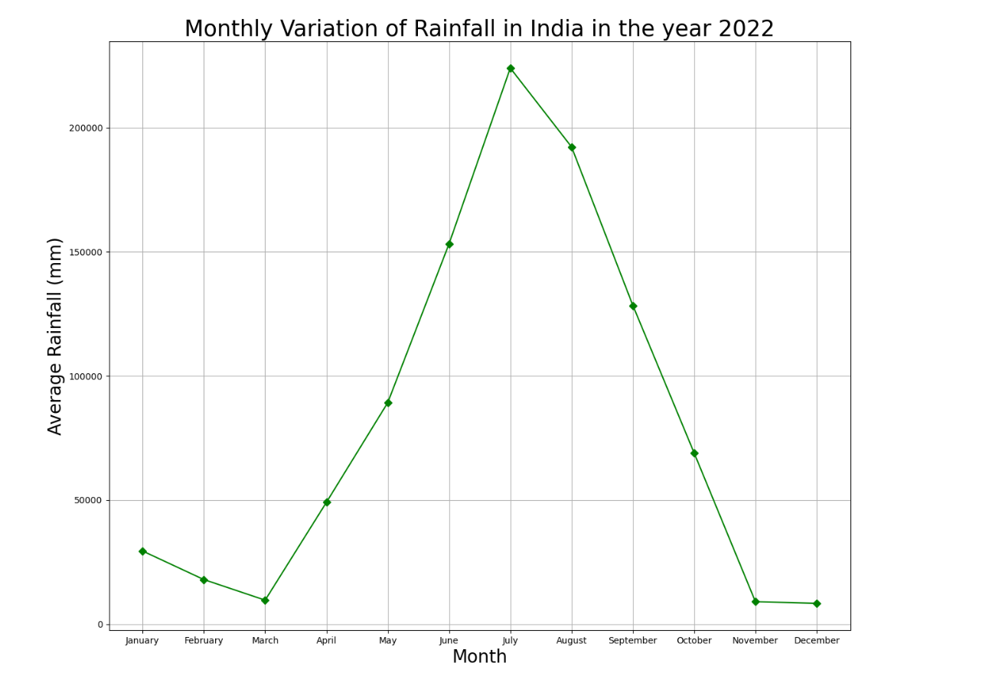**Temporal Trends Identification:** Through time series analysis, the project identifies seasonal and temporal trends, helping understand long-term changes in rainfall distribution.
* **Correlation with Climatic Events**: The project explores potential links between India's rainfall patterns and global climatic phenomena like El Niño and La Niña, offering insights into larger climatic influences.
* **Visualization:** Effective visual representations, including line graphs, choropleth maps, and scatter plots, make complex data accessible and understandable

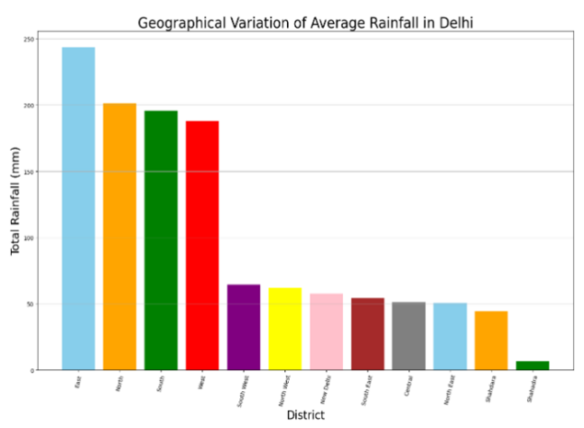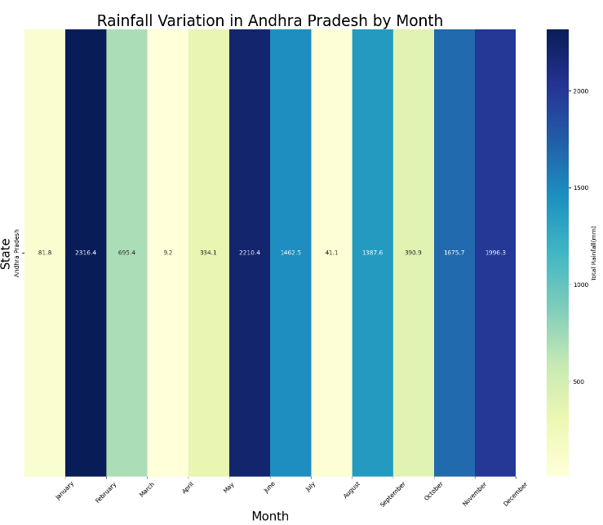

* **Insightful Interpretation**: The project provides meaningful insights into the implications of rainfall patterns on water resources, agriculture, and disaster management.
* **Recommendations:** Based on analysis outcomes, the project offers practical recommendations for tailored water management and climate-resilient agricultural practices.
* **Technical Documentation:** Detailed technical documentation accompanies the project, providing transparent methodologies and analysis procedures for reference.
* **Stakeholder Communication:** The project facilitates effective communication of findings to stakeholders, enabling informed decision-making.
* **Sustainable Development Alignment:** By highlighting the importance of climate-resilient strategies, the project contributes to India's sustainable development goals.

**10.1.Learning Outcomes:**

* **Data Analysis and Interpretation:**

We will be honed the ability to analyze intricate datasets, uncover trends, and derive meaningful conclusions from complex rainfall data.

* **Technical Documentation Proficiency:**

Through preparing detailed technical documentation, we can become skilled in translating complex analysis processes into clear, understandable documentation.

* **Climate Science Awareness:**

This project has deepened the grasp of climate science principles, particularly in understanding how rainfall patterns contribute to larger climatic contexts.

* **Collaborative and Communication Skills:**

Engaging with diverse stakeholders during this project has enhanced teamwork and communication skills, enabling effective interaction in professional environments.

* **Real-world Application of Knowledge:**

Applying theoretical concepts to a practical project has demonstrated the capability to address real-world challenges, showcasing the practical utility of your knowledge.

**11.Conclusion**

The project successfully analysed the rainfall patterns in India during the year 2022 to gain insights into seasonal variations. • Using statistical tools and software, the team processed the data, calculating monthly averages and creating visualizations to present the findings effectively. • The first quarter of the year showed a significant increase in rainfall, providing early-season agricultural advantages. • However, the mid-year period, specifically June and July, experienced an unexpected dip in rainfall, potentially impacting crop growth and water reservoir levels. • Our project shows how analysing rainfall data helps us understand the weather in our area better. The insights we gained can be valuable for people who make decisions about water resources and preparing for different weather conditions caused by climate changes

### **12.References:**

### **Data Analytics Made Accessible, written by Dr Anil Maheshwari,** Published back in 2014

McKinney, W. (2017). Python for Data Analysis. O'Reilly Media.

Website: https://www.kaggle.com/

Description: Source for finding rainfall datasets and basic dataset information.

India Meteorological Department (IMD) - Mausam

https://mausam.imd.gov.in/

Description: Provides information on how rainfall data for every district of India is recorded.